Benefits
Members of the Home Builders Association of Midwest Georgia enjoy benefits from not one but three organizations. While a portion of your dues stay with HBAS to help support the local trade associations, other portions are forwarded to the Home Builders Association of Georgia and National Association of Home Builders. Your tri-level membership helps ensure that the voice of the building industry is heard not only on the local level, but also at the state and national levels. HBAG headquarters are located in Atlanta, GA and the NAHB offices are located in Washington, DC.
By joining the Home Builders Association, you will link up with over 200,000 trade allies throughout the nation. Members include home builders, remodelers, developers, subcontractors, suppliers, manufacturers, financial institutions, interior designers, and many others. The common thread among membership is the desire to add strength to the voice of the building industry through a combined effort.
Each year the National Association of Home Builders hosts The Builders Show, an annual convention attended by over 100,000 building professionals. The convention, usually held in late January or early February, typically changes locations every three years. The NAHB Convention boasts the latest and best in building methods and technology, with over 620,000 square feet of exhibit space! Coupled with hundreds of educational seminars, the NAHB Convention is a must see!
As a member of the Home Builders Association of Midwest Georgia, you can profit from group activities - and learn more about the home building business - by participating in Association programs, special projects, educational workshops, and social events.
For additional information about the Home Builders Association of Midwest Georgia, please contact us at 770-716-7109.

Click here to be redirected to the Member Savings Website: nahb.org/savings

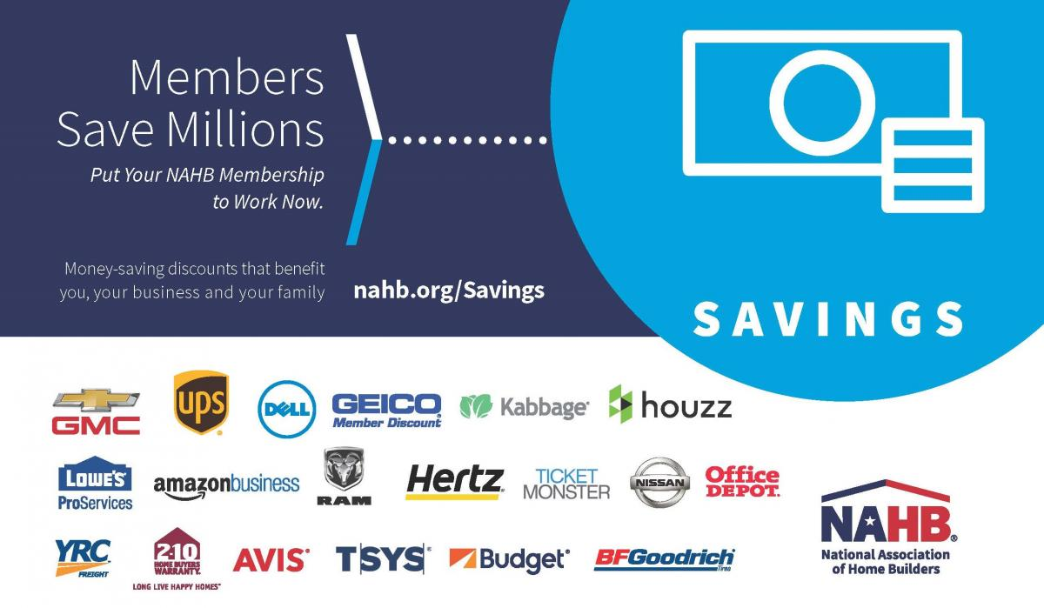

Membership info

Membership level
HBA accepts cash, check, MC, Visa, AMEX and Discover
Builder Membership $580.00
Associate Membership $580.00
Affiliate Membership $150.00

Maybe we could have a link here to the application??

